**ASSIGNMENT 1 SOLUTION**

**NAME: Debasis Mohanty**

**ROLL NO. : UEBA19001**

**Q1.** Golu, a greedy and environmentally conscious small-scale businessman manufactures three items. Production of each of these items give harmful emissions. As discussed in class, design completely with all the parts, an appropriate LP model for Golu. (Refer to the table below). State all your assumptions.

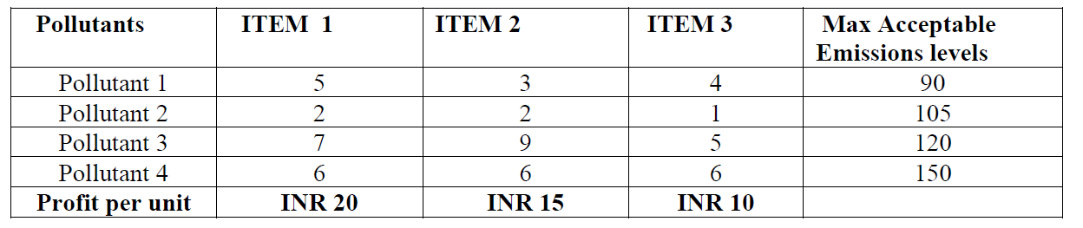

Ans 1:

**Goal** : Maximize Profit while ensuring minimum emission levels.

**Decision Variables :**

$$x_{1}=Number of units to be produced for Item 1$$

$$x_{2}=Number of units to be produced for Item 2$$

$$x_{3}=Number of units to be produced for Item 3$$

**Objective Function :**

$$Max Z=20 x_{1}+15 x_{2}+10 x_{3}$$

**Subject to the below constraints –**

$5x_{1}+3x_{2}+4x_{3}≤90$– Pollutant 1

$2x_{1}+2x_{2}+x_{3}≤105$– Pollutant 2

$7x_{1}+9x_{2}+5x_{3}≤120$– Pollutant 3

$6x_{1}+6x_{2}+6x_{3}≤150$– Pollutant 4

$$x_{1}, x_{2},x_{3}≥0$$

$$x_{1}, x_{2},x_{3} as integers$$

**Assumptions:**

It is assumed that 5 units of **pollutant 1**, 2 units of **pollutant 2**, 7 units of **pollutant 3** and 6 units of **pollutant 4** is emitted for unit production of ITEM 1.

Similarly, it is assumed that 3 units of **pollutant 1**, 2 units of **pollutant 2**, 9 units of **pollutant 3** and 6 units of **pollutant 4** is emitted for unit production of ITEM 2 and 4 units of **pollutant 1**, 1 units of **pollutant 2**, 5 units of **pollutant 3** and 6 units of **pollutant 4** is emitted for unit production of ITEM 3. – NOT REQUIRED as given in question.

All the ITEMS which is produced should be an integer and discrete.

**Q2.** Compare rational decision making, non-rational decision making and boundedly rational decision making

Ans 2:

|  |  |  |
| --- | --- | --- |
| **Rational Decision Making** | **Non-rational Decision Making** | **Boundedly rational Decision Making** |
| * A logical, multi-step model for choosing between alternatives that follows an orderly path from problem identification through mathematical solution. * You have complete information about all the alternatives. * You have enough computational resource to evaluate the alternatives. * The process of rational decision-making favours logic, objectivity, and analysis over subjectivity and insight. | * An experience-based technique for problem solving, learning, and discovery; examples include using a rule of thumb, an educated guess, an intuitive judgment, or common sense. * Intuition information about the alternatives is derived out of experience. * Emotion appears to aid the decision-making process; decisions often occur in the face of uncertainty about whether one’s choices will lead to benefit or harm. * The process of non-rational decision-making favours consideration of personal feelings, loyalties, or sense of obligation. It also considers ethical concerns or the value of altruism. | * Bounded rationality is the idea that an individual’s ability to act rationally is constrained or restricted by the information they have, the cognitive limitations of their minds, and the finite amount of time and resources they have to make a decision. * We have incomplete or imperfect information about the alternatives. * Lack of computational resource to evaluate for all the alternatives. * Bounded rationality is the idea that we make decisions that are rational, but within the limits of the information available to us and our mental capabilities. |